|  |  |
| --- | --- |
| For 1 and 2, Identify whether the following functions are quadratic, answer yes or no. Show your work on how your determined your answer!! | |
| 1.   |  |  | | --- | --- | | X | Y | | -2 | -9 | | -1 | -2 | | 0 | -1 | | 1 | 0 | | 2 | 7 | | 2.   |  |  |  |  |  |  | | --- | --- | --- | --- | --- | --- | | X | -4 | -2 | 0 | 2 | 4 | | Y | 8 | 2 | 0 | 2 | 8 | |
| 3.  Graph the function. Identify the vertex, domain, and range.   |  |  | | --- | --- | | x | y | | -4 |  | | -2 |  | | 0 |  | | 2 |  | | 4 |  |   Vertex: __________________max or min  Domain: _________________  Range: ___________________ | |
| 4. Find the zero’s and axis of symmetry from the graph below.  Zero’s: __________________  Axis of symmetry: _________________  Number of Solutions: ________  Range: ___________________ | |
| 5. Find the axis of symmetry and the vertex of the graph of  Axis of symmetry: __________________  Vertex:  _________________  Range: ___________________  ___________  5a. Describe what would happen to the parabola if the 3 became a 1 and the 8 became a 2.  Use description words like “narrower”, “reflection”, “translated up”, etc. | |

4th Six Weeks Review

6. A model rocket is launched into the sky. The quadratic function $y=-16x^{2}+32x$ models the height in feet of the rocket after *x* seconds.

Max Height: Time of max height: Time in the air:

Solve by graphing

7. y = 3x – 5

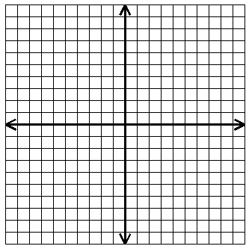

y = -x + 3 solution_____________

8. Solve by substitution y = 3x

x + y = 8 solution _____________

9. Solve by elimination. 5x – 9y = -3

4x – 3y = 6 solution______________

.

10. Solve using any method 2x + y = 9 solution_______________

x + 4y = 1

11. Determine if (5,1) is a solution to the system 4x – 7y = 13

2x – 7y = 3

12.Brianna’s family spent $134 on 2 adult tickets and 3 youth tickets at an amusement park. Max’s family spent $146 on 3 adult tickets and 2 youth tickets. What is the price of a youth ticket?

13. Bill bought some neon fish for $2 each and some angelfish for $3 each for his new aquarium. Bill bought a total of 20 fish and spent a total of $45. How many of each fish did Bill buy?

14.The Strauss family is deciding between two lawn care services. ABC Lawn charges a $49 startup fee, plus $29 per month. True Green charges a $25 startup fee, plus $37 per month. In how many months will both lawn care services cost the same/ What will that cost be?

**Graph each inequality. Give two solutions and two non-solutions to the inequality.**

15.  16.  17.

SHOW ALL WORK:

**Determine whether the given point is a solution for the inequality or system of inequalities: Yes or no?**

|  |  |
| --- | --- |
| 18.  : (-2, -5)  **Answer ________** | 19. 4x + y ≥ -5 : (0, -5)  **Answer ________** |