FIFTH SIX WEEKS TEST REVIEW

1) What is the range for the quadratic function *y* =  *-x²* + 10

2) Square A has a side length of 3x². Square B has a side length of 2x.

A B

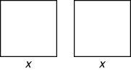

What is the area of square A? ___________ What is the area of square B? ___________

What is the perimeter of square A? ___________ What is the perimeter of square B? ______________

# 3) What is the domain of the graph below?

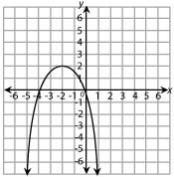

4) The graph of *y* = 2*x*2 ­ 4x + 2 is shown below.

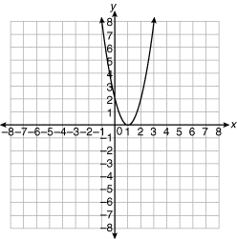

What will be the effect on the graph if the equation is changed to

*Y* = 2*x*2 ­ 4x + 10?

5) The x­intercepts of the graph of a certain quadratic function are (-6, 0) and (-2, 0). What are the solutions to the quadratic equation associated with this function?

# 6) What are the binomial factors of ?

# 7) What are the binomial factors of 3x² - 8 x + 5?

8) What is a solution to this quadratic equation?

0 =  *x*2 *-*  8*x*  + 12

9) What is the factored form of the equation that would create this parabola below?

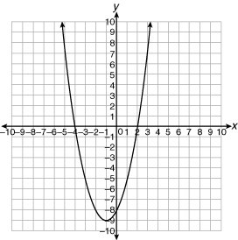

# 10) Use the quadratic formula to find the solutions to 0 = 3x² ­ 3x - 7 (rounded to the nearest hundredths).

11) If the factored form of a quadratic equation is (8x + 3)(x ­ 1) = 0, what are the solutions to the quadratic equation?

12) What is the area of a rectangle with a length of yx² and a width of 6x²y³.

# 13) Would the discriminant (b² ­ 4ac) value of the equation that created this parabola be a positive number, negative number or zero

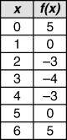Study the table below.

14) What are the zeros of the function, *f*(*x*) =  *ax² + bx + c,* that created this table of values?

15) What is the parent function of the of the equation that created this table of values?

16) If the area of a square is 100x²y², what is the side length of the square?

# 17) What is the GCF factored form of this polynomial expression: 46a²b + 36a³

18) If the factored form of the polynomial

x² + 7x ­ 18 is (x - d)(x + 9), then what is the value of d

19) If the area of a rectangle can be described by x² ­ 17x + 30, what is the length and width of this rectangle?

20) If the roots of a quadratic function *g*(*x*) are *x*  = 9 and  *x* = - 8. Are the

x-intercepts (0, 9) and (0, -8) or (-9, 0) and (8, 0) or neither of these answers.

21) What are the solutions to this quadratic equation: f(x) = (x + 3)(x - 9)

22) Do the graphs of these two quadratic equations have the same zeros? y = -x² - 5x - 4 -12 = 3x² + 15x

23) Show that y = x² + 5x + 12 has no Real Number Solutions without graphing.

24) Which of these tables represents an exponential function

A.  B.  C. Neither

25) A 1000­gram sample of radon is decaying according to the equation below, where *t* is the time in days and *y* is the amount of radon in grams.

*y*  = 1000*(0.83)*t

About what amount of radon will remain after 9.6 days?

26) The number of bacteria, *y*, in a laboratory culture is growing according to the function below, where *x* is the number of hours since the bacteria was introduced into the culture.

*y* = 50(1.05)*x*

Approximately how many bacteria will be in the culture after 36 hours?

ANSWERS

1) y ≤ 10

2) Area of A =; Area of B =; Perimeter of A =; Perimeter of B =

3) All Real Numbers

4) The parabola will shift up 8 units

5) x = -6 and x = -2

6) (y – 6)(y + 2)

7) (3x + 5)(x + 1)

8) one solution is x = 6, one solution is x = 2

9) y = (x – 2)(x + 4)

10) x = 3.11 and x = -0.11

11) x = -3/8 and x = 1

12) Area = 

13) Positive number

14) {5, 1}

15) f(x) = x²

16) 10xy

17) 2a²(23b + 18a)

18) 2

19) (x – 15) length and (x – 2) width

20) neither of these answers

21) x = -3 and x = 9

22) Yes

23) (5)² - (4 • 1 •12) = -23 (negative discriminants have no Real Number Solutions

24) A 25) about 167.2 grams 26) about 290 bacteria