Station 4
Write your answers on your recording sheet!

Write an equation to represent the following.

x | -2 | -1 | 0 | 1
y | -4 | -1 | 2 | 5

- A line passing through the points (0, 3) and (2, 4).

- The soccer booster club plans to sell t-shirts for $10 each.

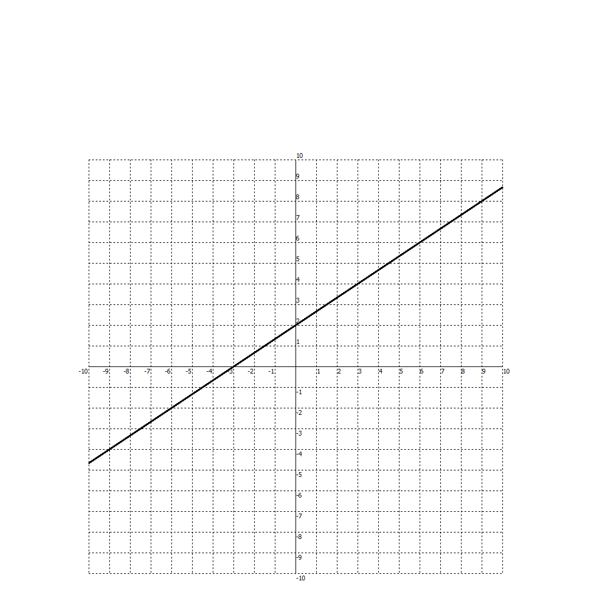

- A line passing through the points (3, 0) and (4, 4).

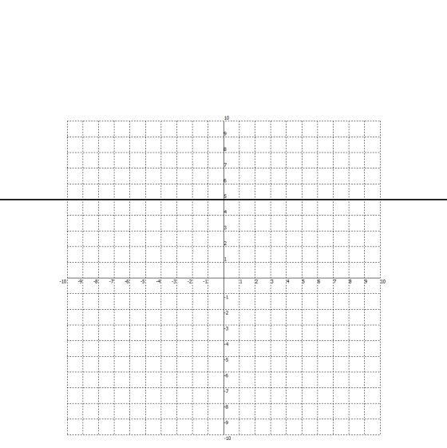
- G)
x | y
-3 | 7
3 | 3
6 | 1
9 | -1

Turn paper over!
- A local fitness center costs $250 to join and $50 per month.

x | 2 | 4 | 8
y | 17 | 14 | 8

- Emily makes a base salary of $100 plus $5 per golf card she sells.

- A line passing through the points (3, -13) and (6, -18).

