Station 3
Write your answers on your recording sheet!
Write the equation, then find the slope, x- and y-intercepts and explain what each mean in context of the problem.

- A hole is punched in the bottom of a monster drink. The drink starts with 550 ml and leaks out at a rate of 5 ml per second.
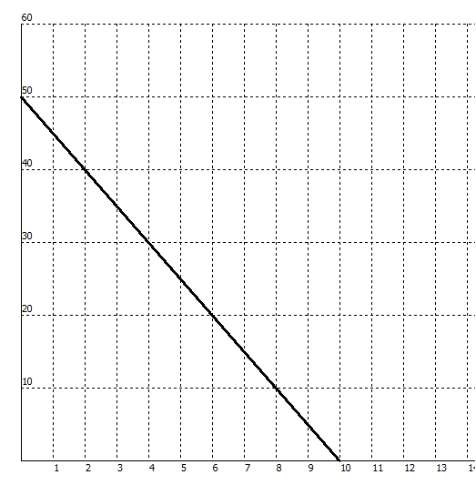
Time (Minutes)
Alyssa’s Walk with Her Dog
Distance from Home (yards)

- The school sells pens for $2.00 and notebooks for $3.00. The equation 2x + 3y = 60 describes the number of pens x and notebooks y that you can buy for $60

